Thank you for your continued support of The Westport Woman’s Club. Your participation is a vital part of helping WWC continue the work started 112 years ago by a small group of woman with a vision, dedicated to volunteerism & philanthropic endeavors to support educational, charitable, cultural, and public health services in our community. To be included in our 2019-2020 Membership Directory, kindly complete and return this form with your dues check by August 31, 2019.

All members are encouraged to get involved by volunteering to help with our fundraisers. Many hands make for light work! Thank you for all you do!

Westport Woman’s Club Membership level: $_____________________ (amount enclosed)

- NEW MEMBER $100.00
- LIFE MEMBER (New): $1000.00 & Over (before Aug. 31, 2019)
- LIFE MEMBER
- ANNUAL MEMBER RENEWAL $100.00 & Over (Sept. 1, 2019 - Aug. 31, 2020)
- ASSOCIATE $35.00 (Residing outside of Fairfield County)

Name: ____________________________________________________________________________

Spouse: ___________________________________________________________________________

Address: __________________________________________________________________________

City, State, Zip: _____________________________________________________________________

Phone: _______________________________ Cell Phone: __________________________________

Email address: ______________________________________________________________________

Emergency Contact: ____________________________________Cell Phone: ____________________
(Emergency Contact will not be printed in directory – office use only)

Employer/Profession:________________________________________________________________

Permanent Lunch List - Club Day:

- YES - PLEASE SIGN ME UP Members on the permanent lunch list that are unable to attend Club Day must cancel by the Wednesday before Club Day to avoid being charged $20.00.

- NO - I WILL CALL IF I PLAN TO ATTEND Members not on the permanent lunch list will need to call and register for lunch by the Wednesday before Club Day in order to attend.
Member – Year Joined ___________________________
(Let us know when you joined the Westport Woman’s Club so that we can ensure our records are up to date)

Please check any Special Interest Groups you'd like to renew, join, explore or launch!

- Art Show
- Book Review
- Bridge
- Bunco
- BYOB Friday
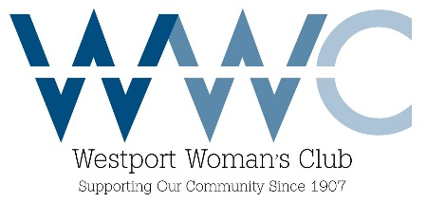
- Canasta
- Community Services/Philanthropy
- Cultural Affairs
- Clothing Sale
- Curio Cottage
- Food Closet
- Friendship/Sunshine Girls
- Fundraisers
- Garden
- Gourmet
- Ladies Who Lunch
- Mah Jongg
- Scholarship/Grant Breakfast
- Yankee Doodle Fair (our biggest fundraiser each year – we need your help!)
- Other Interests: ______________________________________________________________

- BOARD OF DIRECTORS – POSITION INTERESTED IN __________________________________

*Please list a prospective member you would like us to contact & invite to the first membership
Wine & Cheese.

Prospective Member’s Name: _______________________________________________

Address: ________________________________________________Phone:___________

Email address: ____________________________________________________________

